619 Main St. Oregon City - 12-5pm  
Day Long Specials - starting 10am-9pm

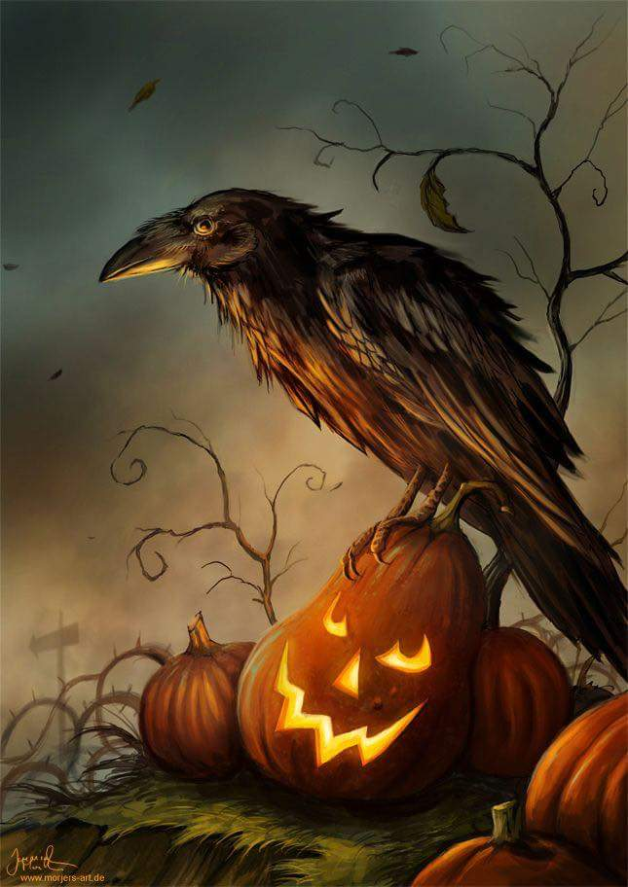

Hearses & Driven Dead Cars

Scarecrow Contest

Painted Rock Contest

Ghost Tours

Original Artists

Face Painting

Saturday October 21st, 2017

Nightmare   
on Main St.

Ghoul Gallery presents